Description | Notes/Request
Abdominal Intramuscular Injection, Pad | 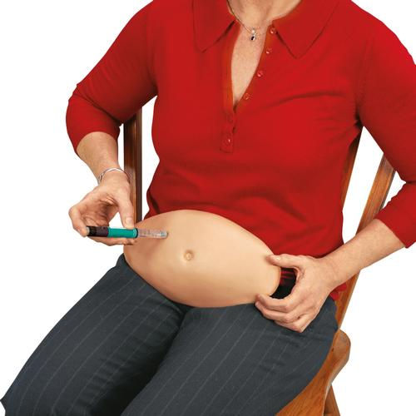
AED 2, Trainer | 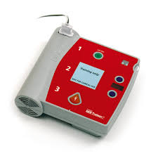
Airway Management AirSim Jr, Trainer | 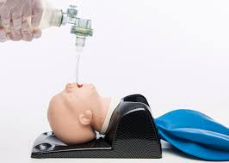
Airway Management AirSim, Trainer | 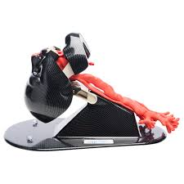
Airway Management Deluxe Difficult, Trainer | 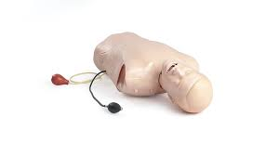
Airway Management Difficult, Trainer
Airway Management Infant, Trainer | 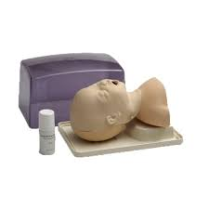
Airway Management, Trainer | 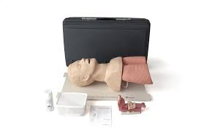
Arterial Arm Stick, Trainer | 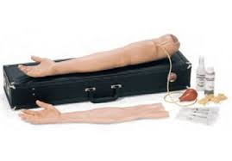
Arterial Puncture Wrist, Trainer | 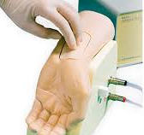
Auscultation Student, Manikin (SAM) | 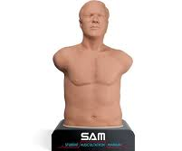
Auscultation Pediatric, Manikin (PAT) | 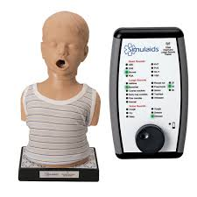
Aspiration (Arthrocentesis) & Injection Model - Knee, Task Trainer  *Additional Knee/Lower Extremity Aspiration Models Available | 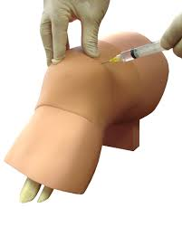
Baby Anne CPR, Trainer | 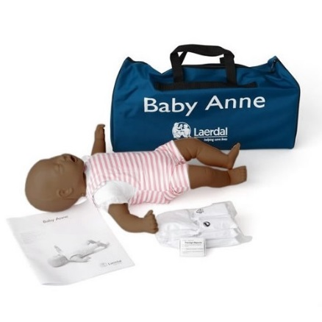  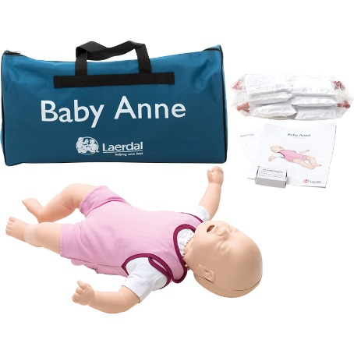
Baby Hippy Trainer | 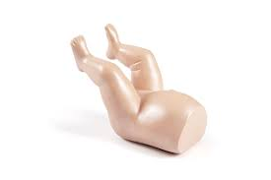
Birthing PROMPT Flex, Simulator  (Optional: PPH Module)  (Optional: Cervical Dilation Module)  (Optional: Force Monitoring Baby PROMPT Flex, Manikin) | 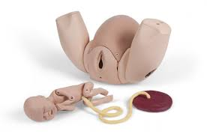  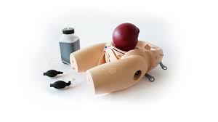  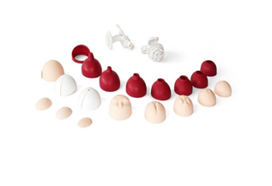
Blood Pressure BP Arm, Trainer | 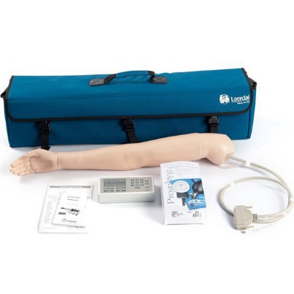
Breast Exam Strap-on, Trainer | 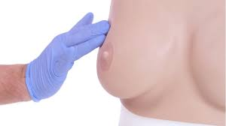
Breast Exam, Trainer | 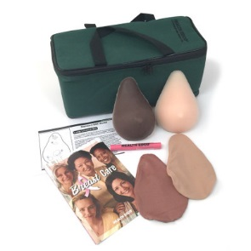  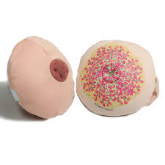  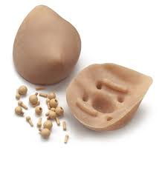
Cardiopulmonary Patient HeartMan Harvey, Simulator | 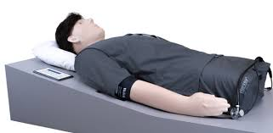
Catheterization Female, with Urine Return, Trainer | 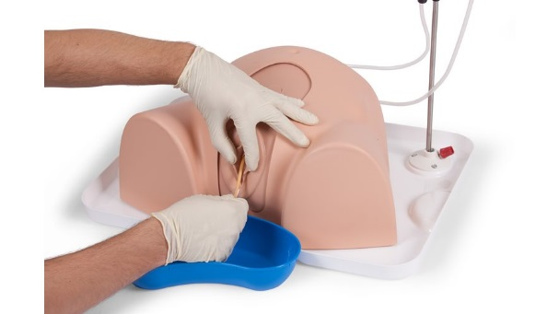
Catheterization Male, with Urine Return, Trainer | 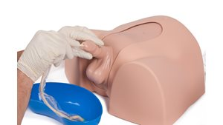
Central Line Catheterization CentralLineMan, Trainer | 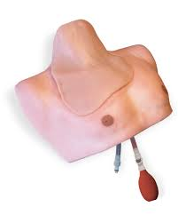
Cervical Dilation, Model | 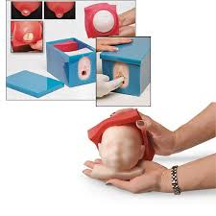  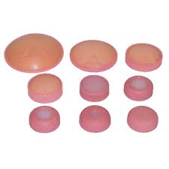
Chest Tube, Manikin | 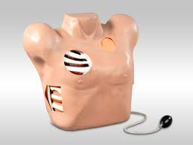
Cricoid Stick, Trainer
Ear Examination, Simulator | 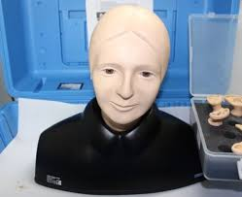
Empathy Pregnancy Belly | 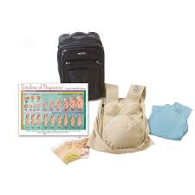
Endoscopic Dexterity, Trainer | 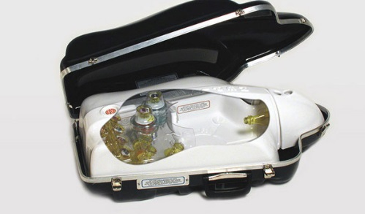
EpiPen Trainer | 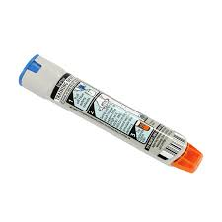
Eye Examination, Simulator | 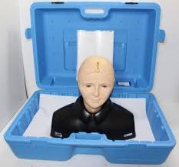
Fetal Monitoring & Labor Progress, Model
Geriatric Patient, Simulator | 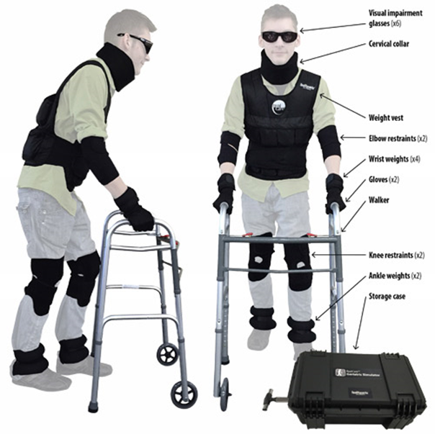
Gynecology Diagnostic Training, Model | 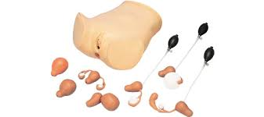
Heart, Model | 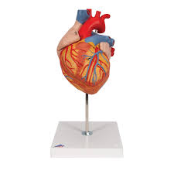
Injection, Joint Model  (Available: Elbow & Shoulder) | 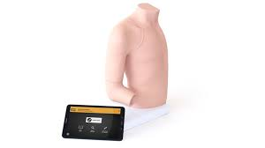
Injection Pad | 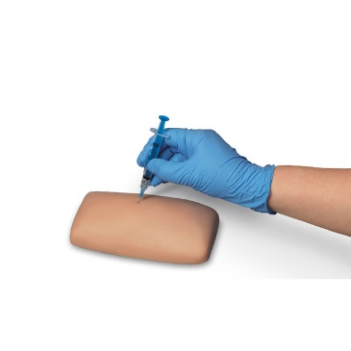
Injection Inject-Ed, Pad | 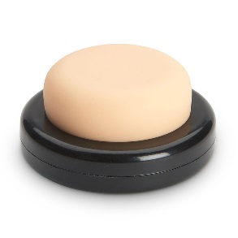
Injection Intradermal, Pad | 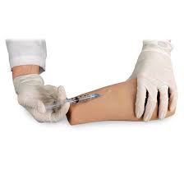
Injection Intramuscular & Subcutaneous, Pad  *Additional Subcutaneous injection Pads Available | 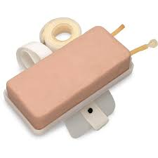
Injection Intramuscular, Simulator | 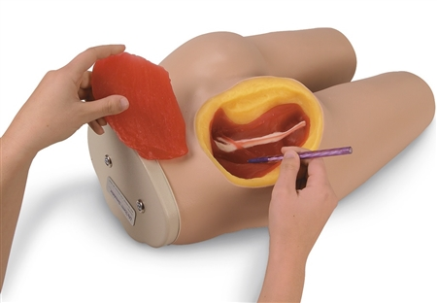
Injection Small Paddy, Pad | 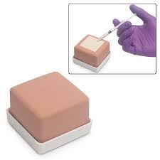
Insulin Pen Trainer | 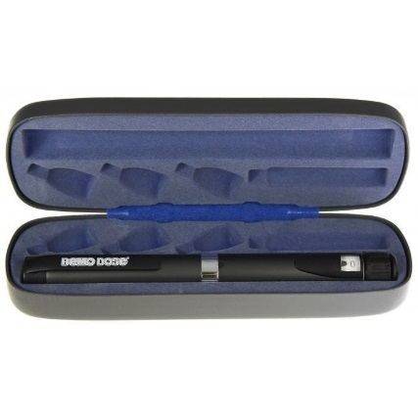
Interchangeable Catheterization & Enema, Trainer | 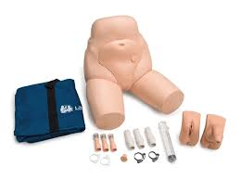
Intraosseous Infusion, Simulator  Models Available:  Humerus, Infant, & Leg | 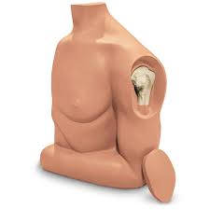  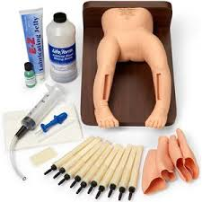  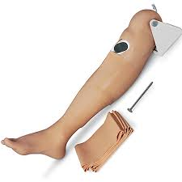
Intubation Infant, Model | 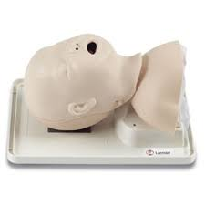
Intubation Neonatal, Trainer | 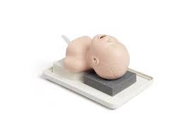
IV Arm, Trainer | 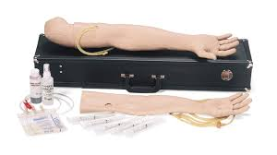
IV Injection Hand, Trainer | 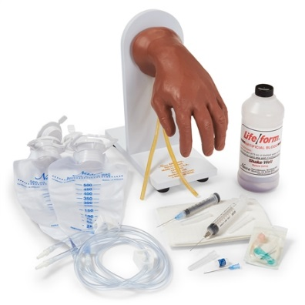
Lactation Task Trainer
Little Anne AED, Trainer | 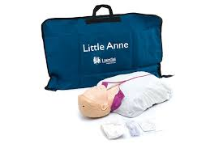
LMA CTrach, Trainer | 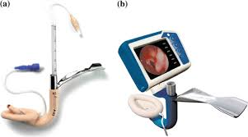
Lumbar Puncture Baby, Trainer  + Baby Lumbar Model | 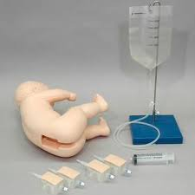
Lumbar Puncture,  Simulator I & II | 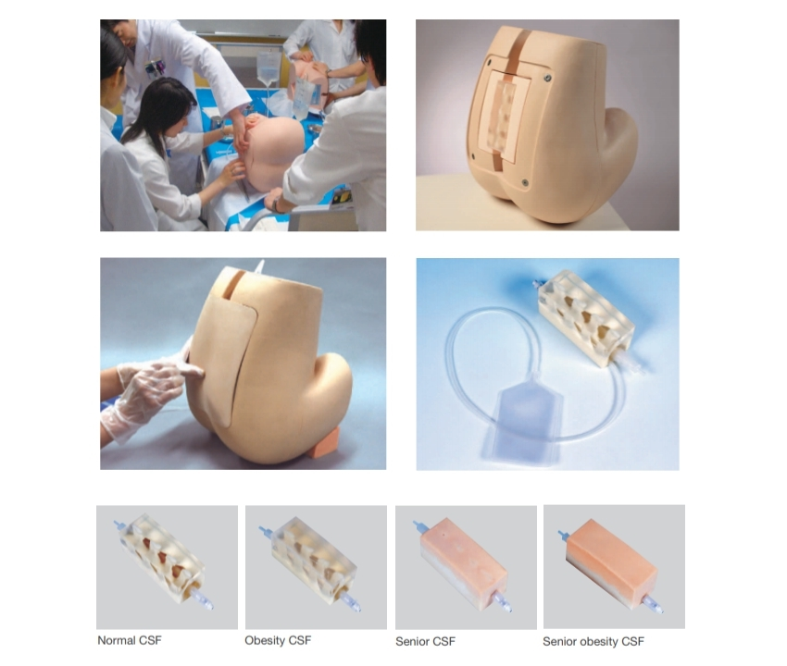
Lung, Model | 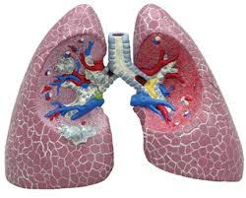
MamaNatalie Birthing Simulator Light, Task Trainer | 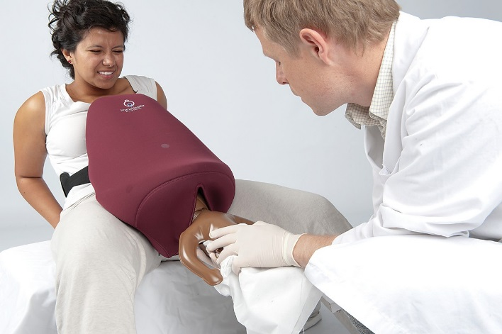
Nasogastric Intubation Teaching, Model | 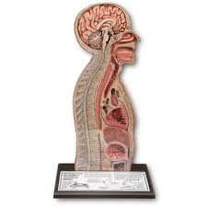
Ostomy Care, Model
Pediatric IV Trainer  (Pump, Circulation) | 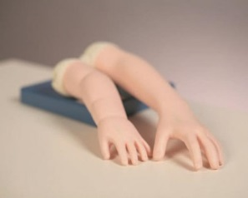
Pelvic Exam, Trainer
(Optional: Fibroid Uterus, Ovarian Cyst, Retroverted Uterus)
Pitting Edema, Model  (Optional: No Edema, +1, +2, +3, +4) | 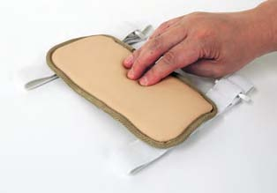
Pelvis, Model | 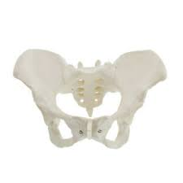
Pneumothorax, Simulator | 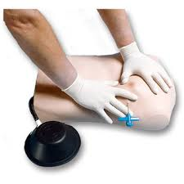
ShockLink | 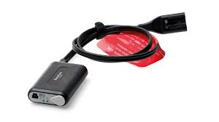
Sim Pad & SimPad Plus | 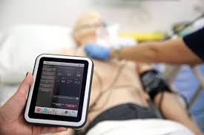
Sim-Tie, Sim Vivo  Suturing Practice | 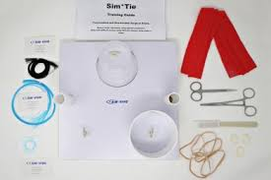
Testicle Model  Available Options:  2 Lumps in 1, 2 Lumps in 2 | 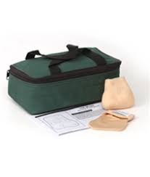
Ultrasound Blue Phantom, Trainer | 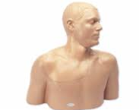  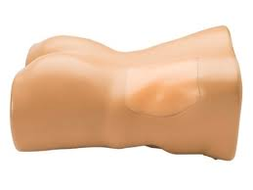
Upper Torso, Model | 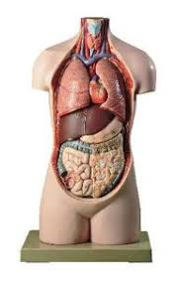
Vascular Access Chester Chest, Trainer | 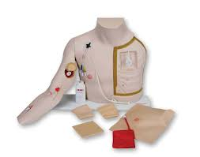
Ventriloscope, Simulated Stethoscope | 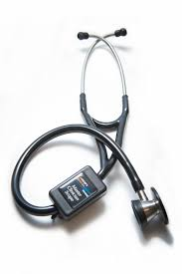
Wound Care Decubitis Seymour Butts, Model | 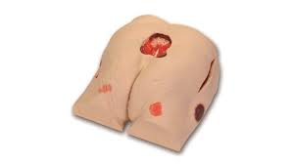
Wound Care Surgical Sally, Model | 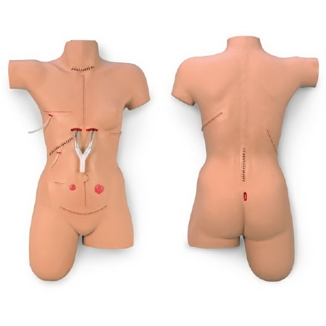
Wound Packing, Trainer &  Wound Packing Blocks | 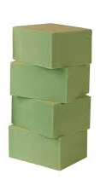
Items not pictured: | Brachial Plexus/Shoulder Model, Brain Model, Dermatology Model, Skeleton Leg Model
 | Additional Resources
Manikin Quick Guide
Static Manikin -Skills Manikin
To be used in Training Rooms
Used For:
Transfers, Positioning, Foleys & IV's Age Range Available: Newborn, Infant, Child [4y/o-11y/o], Adult
Lo-Fidelity Manikin - Skills Manikin To be used in Training Rooms
Used for:
Adjusting vitals with SimPad. Has heart, lung, and bowel sounds.
Age Range Available: Adult
Hi-Fidelity Manikin-
Simulation Manikin
Used for:
Simulation cases. Vitals can be altered and projected on monitor. Has heart, lung & bowel sounds. Speaking ability. Can be intubated & defibrillated (please check if shock link needed).
Age Range Available: Newborn, Baby (6-9 mo), Baby (9-12mo), Child (4-11y/o), Adult
DME
Bladder Scanner
Blood Glucose Monitors (Regular & Simulated/Programmable) & Blood Glucose Simulated Finger (SA FingerStick Kit) | 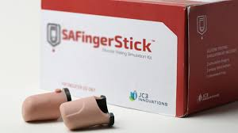
Commode
Enteral Feeding Pump
Foot Cradles
IV Machines | Alaris, Alaris Pain PCA Pump, Baxter, Plum, PlumXL
Patient Lift (Full)
Patient Lift (Standing)
Portable Exam Lights
Portable Oxygen Tanks
Pulse Oximeter (Regular & Simulated/Programmable)
SCD Machine
Seizure Pads
Stand up scales
Temperature (Regular & Simulated/Programmable)
Walker, Wheelchair, Cane (single & quad), Slideboard
WOW's (Workstation on Wheels) w/EMR
Demo Boxes
Fecal & Urinary management Box
IV Demo Box
NG Demo Box
Ostomy Demo Box
Oxygen Demo Box
Restraint Box
Wound Care Demo Box
Virtual Resources
PCS Spark - Virtual Reality Pt, 2 students per session/recommended to use Oculus Headset
VSim- Screen based virtual patient

